**Unit-I Web Environment**

Introduction, History, Client Server Architecture, Web Site Design

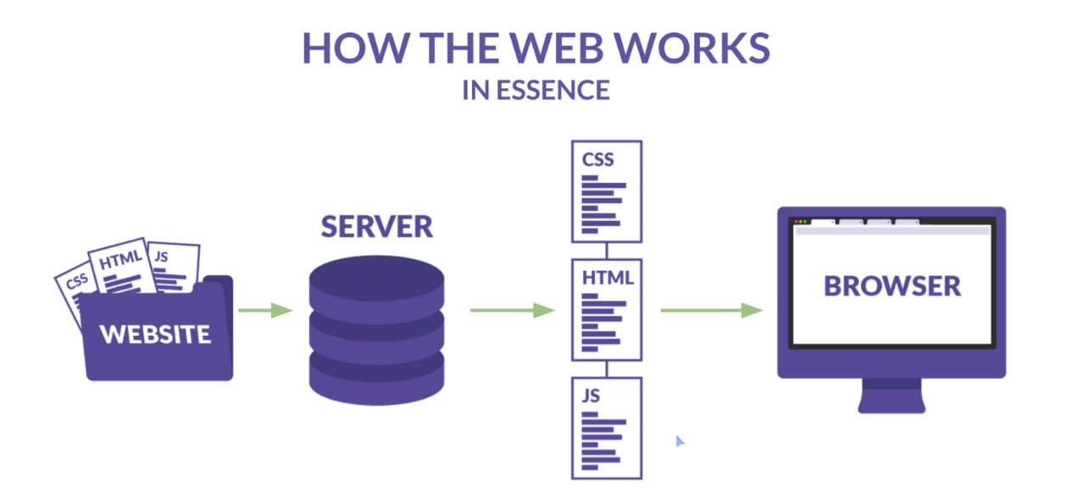

**Introduction**

**What is Internet?**

The Internet is essentially a global network of computing resources. You can think of the Internet as a physical collection of routers and circuits as a set of shared resources.

Some common definitions given in the past include –

* A network of networks based on the TCP/IP communications protocol.
* A community of people who use and develop those networks.
* A community of people who use and develop those networks.

**Internet-Based Services**

Some of the basic services available to Internet users are −

* **Email** − A fast, easy, and inexpensive way to communicate with other Internet users around the world.
* **Telnet** − Allows a user to log into a remote computer as though it were a local system.
* **FTP** − Allows a user to transfer virtually every kind of file that can be stored on a computer from one Internet-connected computer to another.
* **UseNet news** − A distributed bulletin board that offers a combination news and discussion service on thousands of topics.
* **World Wide Web (WWW)** − A hypertext interface to Internet information resources.

**What is WWW?**

WWW stands for **W**orld **W**ide **W**eb. A technical definition of the World Wide Web is − All the resources and users on the Internet that are using the Hypertext Transfer Protocol (HTTP).

A broader definition comes from the organization that Web inventor Tim Berners-Lee helped found, the World Wide Web Consortium (W3C): The World Wide Web is the universe of network-accessible information, an embodiment of human knowledge.

In simple terms, The World Wide Web is a way of exchanging information between computers on the Internet, tying them together into a vast collection of interactive multimedia resources.

**What is HTTP?**

HTTP stands for **H**ypertext **T**ransfer **P**rotocol. This is the protocol being used to transfer hypertext documents that makes the World Wide Web possible.

A standard web address such as [Yahoo.com](http://www.yahoo.com/) is called a URL and here the prefix **http** indicates its protocol

**What is URL?**

URL stands for **U**niform **R**esource **L**ocator, and is used to specify addresses on the World Wide Web. A URL is the fundamental network identification for any resource connected to the web (e.g., hypertext pages, images, and sound files).

**A URL will have the following format −**

protocol://hostname/other_information

The protocol specifies how information is transferred from a link. The protocol used for web resources is HyperText Transfer Protocol (HTTP). Other protocols compatible with most web browsers include FTP, telnet, newsgroups, and Gopher.

The protocol is followed by a colon, two slashes, and then the domain name. The domain name is the computer on which the resource is located.

Links to particular files or subdirectories may be further specified after the domain name. The directory names are separated by single forward slashes.

**What is Website?**

Website is a collection of various pages written in HTML markup language. This is a location on the web where people can find tutorials on latest technologies. Similarly, there are millions of websites available on the web.

Each page available on the website is called a *web page* and first page of any website is called *home page* for that site.

**What is Web Server?**

Every Website sits on a computer known as a Web server. This server is always connected to the internet. Every Web server that is connected to the Internet is given a unique address made up of a series of four numbers between 0 and 256 separated by periods. For example, 68.178.157.132 or 68.122.35.127.

When you register a Web address, also known as a domain name, such as tutorialspoint.com you have to specify the IP address of the Web server that will host the site.

We will see different type of Web servers in a separate chapter.

**What is Web Browser?**

Web Browsers are software installed on your PC. To access the Web you need a web browsers, such as Netscape Navigator, Microsoft Internet Explorer or Mozilla Firefox.

Currently you must be using any sort of Web browser while you are navigating through my site tutorialspoint.com. On the Web, when you navigate through pages of information this is commonly known as *browsing or surfing*.

We will see different type of Web browsers in a separate chapter.

**What is SMTP Server?**

SMTP stands for **S**imple **M**ail **T**ransfer **P**rotocol Server. This server takes care of delivering emails from one server to another server. When you send an email to an email address, it is delivered to its recipient by a SMTP Server.

**What is ISP?**

ISP stands for **I**nternet **S**ervice **P**rovider. They are the companies who provide you service in terms of internet connection to connect to the internet.

You will buy space on a Web Server from any Internet Service Provider. This space will be used to host your Website.

**What is HTML?**

HTML stands for **H**yper **T**ext **M**arkup **L**anguage. This is the language in which we write web pages for any Website. Even the page you are reading right now is written in HTML.

This is a subset of Standard Generalized Mark-Up Language (SGML) for electronic publishing, the specific standard used for the World Wide Web.

**What is Hyperlink?**

A hyperlink or simply a link is a selectable element in an electronic document that serves as an access point to other electronic resources. Typically, you click the hyperlink to access the linked resource. Familiar hyperlinks include buttons, icons, image maps, and clickable text links.

**What is DNS?**

DNS stands for **D**omain **N**ame **S**ystem. When someone types in your domain name, www.example.com, your browser will ask the Domain Name System to find the IP that hosts your site. When you register your domain name, your IP address should be put in a DNS along with your domain name. Without doing it your domain name will not be functioning properly.

**What is W3C?**

W3C stands for **W**orld **W**ide **W**eb Consortium which is an international consortium of companies involved with the Internet and the Web.

The W3C was founded in 1994 by Tim Berners-Lee, the original architect of the World Wide Web. The organization's purpose is to develop open standards so that the Web evolves in a single direction rather than being splintered among competing factions. The W3C is the chief standards body for HTTP and HTML.

On the simplest level, the Web physically consists of the following components −

* **Your personal computer** − This is the PC at which you sit to see the web.
* **A Web browser** − A software installed on your PC which helps you to browse the Web.
* **An internet connection** − This is provided by an ISP and connects you to the internet to reach to any Website.
* **A Web server** − This is the computer on which a website is hosted.
* **Routers & Switches** − They are the combination of software and hardware who take your request and pass to appropriate Web server.

The Web is known as a *client-server system*. Your computer is the client and the remote computers that store electronic files are the servers.

**How the Web Works**

When you enter something like [Google.com](http://www.google.com/) the request goes to one of many special computers on the Internet known as *Domain Name Servers***(DNS)**. All these requests are routed through various routers and switches. The domain name servers keep tables of machine names and their IP addresses, so when you type in [Google.com](http://www.google.com/) it gets translated into a number, which identifies the computers that serve the Google Website to you.

When you want to view any page on the Web, you must initiate the activity by requesting a page using your browser. The browser asks a domain name server to translate the domain name you requested into an IP address. The browser then sends a request to that server for the page you want, using a standard called Hypertext Transfer Protocol or HTTP.

The server should constantly be connected to the Internet, ready to serve pages to visitors. When it receives a request, it looks for the requested document and returns it to the Web browser. When a request is made, the server usually logs the client's IP address, the document requested, and the date and time it was requested. This information varies server to server.

An average Web page actually requires the Web browser to request more than one file from the Web server and not just the HTML / XHTML page, but also any images, style sheets, and other resources used in the web page. Each of these files including the main page needs a URL to identify each item. Then each item is sent by the Web server to the Web browser and Web browser collects all this information and displays them in the form of Web page.

## In Short

We have seen how a Web client - server interaction happens. We can summarize these steps as follows −

* A user enters a URL into a browser (for example, [Google.com](http://www.google.com/). This request is passed to a domain name server.
* The domain name server returns an IP address for the server that hosts the Website (for example, 68.178.157.132).
* The browser requests the page from the Web server using the IP address specified by the domain name server.
* The Web server returns the page to the IP address specified by the browser requesting the page. The page may also contain links to other files on the same server, such as images, which the browser will also request.
* The browser collects all the information and displays to your computer in the form of Web page.

**History of web environment**

<https://home.cern/science/computing/birth-web/short-history-web>

https://www.youtube.com/watch?v=k0gvAyCubGQ

Tim Berners-Lee wrote the first proposal for the World Wide Web in March 1989 and his second proposal in May 1990. Together with Belgian systems engineer Robert Cailliau, this was formalised as a management proposal in November 1990. This outlined the principal concepts and it defined important terms behind the Web. The document described a "hypertext project" called "WorldWideWeb" in which a "web" of "hypertext documents" could be viewed by “browsers”.By the end of 1990, Tim Berners-Lee had the first Web server and browser up and running at CERN, demonstrating his ideas. He developed the code for his Web server on a NeXT computer. To prevent it being accidentally switched off, the computer had a hand-written label in red ink: "This machine is a server. **DO NOT POWER IT DOWN!!"**

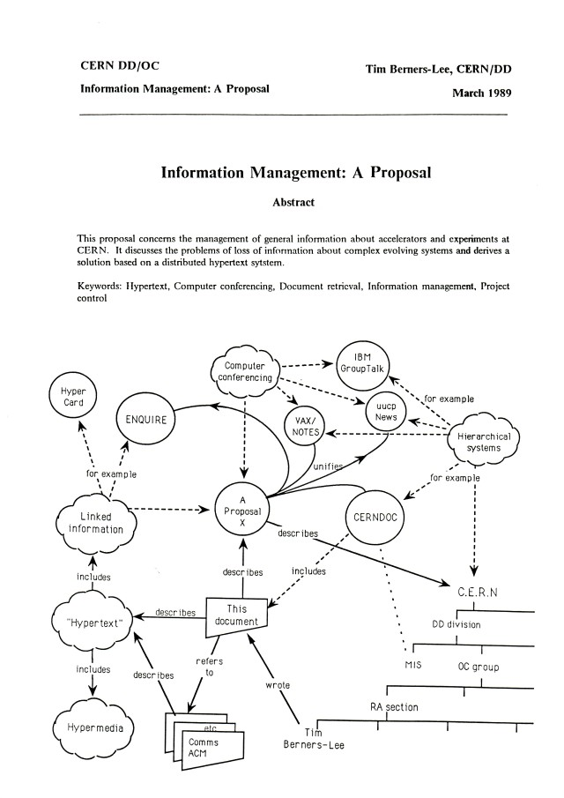

**Client Server Architecture**

A Client-Server Architecture consists of two types of components: clients and servers. A server component perpetually listens for requests from client components. When a request is received, the server processes the request, and then sends a response back to the client. Servers may be further classified as stateless or stateful. Clients of a stateful server may make composite requests that consist of multiple atomic requests. This enables a more conversational or transactional interactions between client and server. To accomplish this, a stateful server keeps a record of the requests from each current client. This record is called a session.

In order to simultaneously process requests from multiple clients, a server often uses the Master-Slave Pattern. In this case the Master perpetually listens for client requests. When a request is received, the master creates a slave to processes the request, and then resumes listening. Meanwhile, the slave performs all subsequent communication with the client.

Client-Server Architecture is a shared architecture system where loads of client-server are divided. The client-server architecture is a centralized resource system where server holds all the resources. The server receives numerous performances at its edge for sharing resources to its clients when requested. Client and server may be on the same or in a network. The server is profoundly stable and scalable to return answers to clients. This Architecture is Service Oriented which means client service will not be interrupted. Client-Server Architecture subdues network traffic by responding to the inquiries of the clients rather than a complete file transfer. It restores the file server with the database server.

Client computers implement a bond to allow a computer user to request services of the server and to represent the results the server returns. Servers wait for requests to appear from clients and then return them. A server usually gives a standardized simple interface to clients to avoid a hardware/software confusion. Clients are located at workplaces or on personal machines, at the same time servers will be located somewhere powerful in the network. This architecture is useful mostly when clients and the server each have separate tasks that they routinely perform. Many clients can obtain the server’s information concurrently, and also a client computer can execute other tasks, for instance, sending e-mails.

**Types of Client Server Architecture**

**1-tier architecture**

In this category of client-server setting, the user interface, marketing logic and data logic are present in the same system. This kind of service is reasonable but it is hard to manage due to data variance that allots replication of work. One-tier architecture consists of layers.

For example, Presentation, Business, Data Access layers within a single software package. The data is usually stored in the local system or a shared drive. Applications which handle all the three tiers such as MP3 player, MS Office come under one-tier application.

**2-tier architecture**

In this type of client-server environment, the user interface is stored at client machine and the database is stored on the server. Database logic and business logic are filed at either client or server but it needs to be maintained. If Business Logic and Data Logic are collected at a client side, it is named as fat client thin server architecture. If Business Logic and Data Logic are handled on the server, it is called thin client fat server architecture. This is considered as affordable.

In two-tier architecture, client and server have to come in direct incorporation. If a client is giving an input to the server there shouldn’t be any intermediate. This is done for rapid results and to avoid confusion between different clients. For instance, online ticket reservations software use this two-tier architecture.

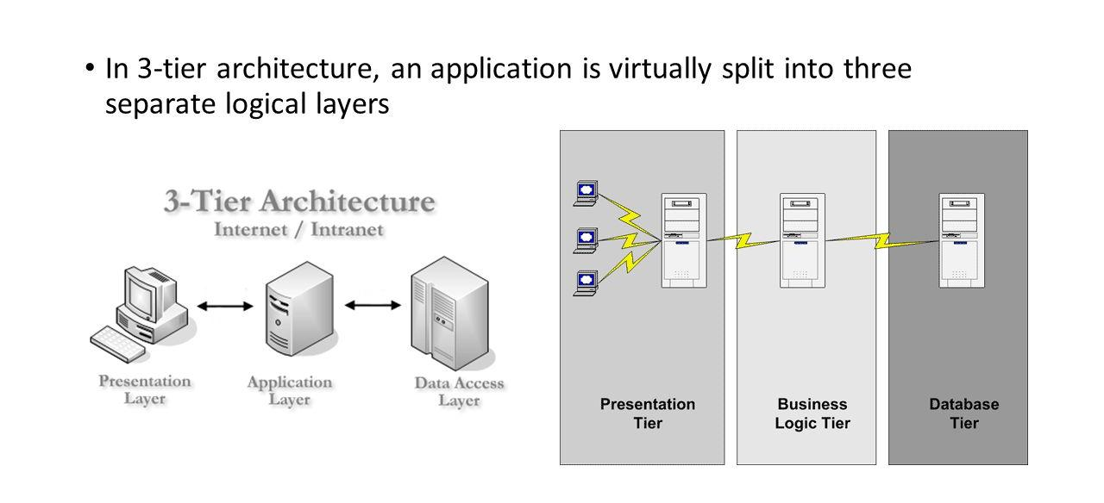

**3-tier client-server architecture**

**3-tier architecture**

In this variety of client-server context, an extra middleware is used that means client request goes to the server through that middle layer and the response of server is received by middleware first and then to the client. This architecture protects 2-tier architecture and gives the best performance. This system comes expensive but it is simple to use. The middleware stores all the business logic and data passage logic. The idea of middleware is to database staging, queuing, application execution, scheduling etc. A Middleware improves flexibility and gives the best performance.

The Three-tier architecture is split into 3 parts, namely, The presentation layer (Client Tier), Application layer (Business Tier) and Database layer (Data Tier). The Client system manages Presentation layer; the Application server takes care of the Application layer, and the Server system supervises Database layer.

In the present scenario of online business, there has been growing demands for the quick responses and quality services. Therefore, the complex client architecture is crucial for the business activities. Companies usually explore possibilities to keep service and quality meet to maintain its marketplace with the help of client-server architecture. The architecture increases productivity through the practice of cost-efficient user interfaces, improved data storage, expanded connectivity and secure services.

**Web Site Design**

Everything about your website - including the content, the way it looks, and the way it works - is determined by the website design. Web design is a process of conceptualizing, planning, and building a collection of electronic files that determine the layout, colors, text styles, structure, graphics, images, and use of interactive features that deliver pages to your site visitors. Professional Web design helps to make your business appear credible online.

When you're ready to build a website, you have several options. If you are not familiar with HTML programming language and Web design applications, there are a number of other options for creating your Web design:

1. Hire a professional website design expert to create and build a unique Web site.
2. Create your own website design using off-the-shelf software such as FrontPage® or Dreamweaver®. (These software packages do require technical expertise.)
3. Use online website design tools with pre-set and/or customizable Web design templates to customize with your company colors, graphics and text.
4. The degree of customization included in your website design will determine the speed and cost of getting your site up and running.

**How Can Professional Web Design Help My Online Business?**

As important as having a great domain name, professional web design can help you:

1. Satisfy customers. Professional Web design meets the needs of your visitors – telling them quickly what they want to know without unnecessary and confusing design items. Making sure the navigation in your Web site design is predictable, consistent and easy to understand will help build a positive relationship with your visitors.
2. Attract search engines. No matter how appealing your Web site design looks, it won't show up on the search engine results pages if it's not coded in a way that the search engines can read.
3. Avoid technical glitches. It doesn't take much to turn a customer away. Lengthy loading times, broken links and dropped images are just a few of the web design issues that can be remedied by a professional Web design service.

By reaching out to customers and search engines alike, Web site design serves an important dual purpose that has a great impact on your online sales.

**How Can Network Solutions® Help Me with Web Site Design?**

Network Solutions provides customized, professional Web design packages that allow you to have a professional website design worthy of representing your company. You may choose to work one-on-one with a professional Web design expert to design and build your website using the latest Web site design techniques, or you may take a more hands-on approach and use customizable Web site design templates to build the website yourself. Either way, Network Solutions professional Web design tools and Web hosting packages can help to ensure that your Web site design looks great and does exactly what it is meant to do: meet the needs of your customers.